**Financial Model Case Study**

On

**Analysis of 50 Flats Housing Project in Gurgaon, Haryana IN**

Name : Suraj Yadav

Email : [23m0211@iitb.ac.in](mailto:23m0211@iitb.ac.in)

Contact : 9867116164

IIT Bombay

**\**

**Project Title : Financial Modeling and Analysis of 50 Flats Housing Project in Gurgaon, Haryana IN**

Techvardhan Infra Pvt. Ltd (Any Company) “CLIENT” has acquired a piece of land near Gurugram HR and wants to develop it as a residential building having 50 flats of 900 sq. ft each.They are expecting to sell the flats at a rate of Rs. 4000 / sq.ft. The expected CapEx is Rs. 8 Crore and OpEx is Rs. 50 Lacs / per annum for the whole project.They are seeking a non-recourse debt (project financing) with 70:30 as D/E ratio from leading commercial banks in India as a 12 years term loan.Please prepare a financial model and analyse the cost, revenue and debt repayment along with finflow / cash flow analysis. Calculate equity IRR and DSCR.

**Contents**

1. Introduction 4

1.1. Assumptions 5

2. Cost Analysis 5

3. Revenue Analysis 6

3.1 Project Parameter: 6

3.2 Different elements and definitions: 7

3.3. Interest on Deposit: 8

3.4 Revenue (million INR): 9

4. Finance Flow 9

4.1. EBITDA Analysis : (Earnings Before Interest, Taxes, Depreciation, and Amortization) 11

4.2. Debt Repayment: 12

4.3. EBIT (Earnings Before Interest and Taxes) 12

4.4. Cash Flow 13

4.5. Debt Balance : 14

5. Result and conclusion : 15

**Figure of context**

[Figure 1 Rent analysis of project (year on year) 9](https://d.docs.live.net/a1b47e7d4370dbdc/Documents/Case.docx#_Toc138511980)

[Figure 2 Interest on deposit analysis of project (year on year) 9](https://d.docs.live.net/a1b47e7d4370dbdc/Documents/Case.docx#_Toc138511981)

[Figure 3 Revenue analysis of project (year on year) 10](https://d.docs.live.net/a1b47e7d4370dbdc/Documents/Case.docx#_Toc138511982)

[Figure 4 EBITDA analysis of project (year on year) 12](https://d.docs.live.net/a1b47e7d4370dbdc/Documents/Case.docx#_Toc138511983)

[Figure 5 Debt Repayment analysis of project (year on year) 13](https://d.docs.live.net/a1b47e7d4370dbdc/Documents/Case.docx#_Toc138511984)

[Figure 6 EBIT analysis of project (year on year) 13](https://d.docs.live.net/a1b47e7d4370dbdc/Documents/Case.docx#_Toc138511985)

[Figure 7 Cash Flow analysis of project (year on year) 14](https://d.docs.live.net/a1b47e7d4370dbdc/Documents/Case.docx#_Toc138511986)

[Figure 8 Debt Balance analysis of project (year on year) 15](https://d.docs.live.net/a1b47e7d4370dbdc/Documents/Case.docx#_Toc138511987)

**Table of context**

Table 1 some project details 6

Table 2 assumption taken to initiate the project 7

Table 3 Revenue Parameter for the project 8

# **Introduction**

In the case of the provided financial modelling problem, the objective is to analyse the cost, revenue, and debt repayment for a construction project. By making assumptions about the land cost, construction time, sales rate, sales time, Capital Expenditure (CapEx), and Operating Expenditure (OpEx), we can calculate various financial metrics. These include revenue, operating expenses, EBITDA (Earnings Before Interest, Taxes, Depreciation, and Amortization), non-operating expenses, net income, and cash flow. Additionally, we can determine the equity Internal Rate of Return (IRR) and Debt Service Coverage Ratio (DSCR) to assess the project's financial viability and repayment capacity.

Financial modelling is a powerful tool that helps businesses and individuals make informed financial decisions, evaluate investment opportunities, secure financing, and plan for the future. It provides a systematic and quantitative approach to assess and forecast financial outcomes, enabling stakeholders to mitigate risks, optimize resources, and maximize value.

To solve the given financial modelling problem and analyse the cost, revenue, and debt repayment, I will make some assumptions based on the information provided. Please note that these assumptions are not provided explicitly, so I will use reasonable assumptions to proceed with the analysis.

## **Assumptions**

* Land Cost: The land cost is not mentioned in the information provided. Let's assume it to be Rs. 2 Crore.
* Construction Time: The construction time is mentioned as 0.25 years (3 months) in the information provided.
* Sales Rate: The expected sales rate is mentioned as Rs. 4000/sq. Ft.
* Sales Time: Let's assume it takes 1 year (12 months) to sell all the flats from the date of completion of construction.
* CapEx: The expected Capital Expenditure (CapEx) is mentioned as Rs. 8 Crore.
* OpEx: The expected Operating Expenditure (OpEx) is mentioned as Rs. 50 Lacs per annum.
* Based on the assumptions, we can calculate the revenue, operating expenses, EBITDA, non-operating expenses, net income, and cash flow. We can also calculate the equity Internal Rate of Return (IRR) and Debt Service Coverage Ratio (DSCR).

Table 1 some project details

|  |  |  |
| --- | --- | --- |
| PROJECT DETAILS | | |
| Size in Sq. Ft | 3000 | 12.23 |
| Equity | 30% | 3.67 |
| Debt | 70% | 8.56 |
| Debt Service Resv (DSR) | 0.25 yrs |  |

Table 2 assumption taken to initiate the project

|  |  |  |  |  |  |
| --- | --- | --- | --- | --- | --- |
| ASSUMPTIONS | | | | | |
| Inflation | 4.00% | Debt rate | 10.0% | USD/INR | 70.00 |
| DDT | 0.00% | Moratorium | 0.25 yrs | Discount | 10% |
| Tax Holiday | 0 yrs | Debt tenure | 10.0 yrs | MAT | 18.5% |
| Tax rate | 25.00% | Depreciation | 7.00% |  |  |
|  |  |  |  |  |  |

# **Cost Analysis**

The given information provides details about project costs and operational and maintenance (O&M) costs associated with a project involving the construction of 50 flats.

Project Cost (CapEx): This refers to the capital expenditure (CapEx) incurred for the entire project. In this case, the total project cost for constructing 50 flats is stated as 8,00,00,000 Rupees, which means the estimated cost for completing the project is 8 crore Rupees.

O&M Cost (OpEx): Operational and maintenance (O&M) costs represent the ongoing expenses required for the operation and upkeep of the project. The information provides the monthly breakdown of these costs. The total O&M cost per year is stated as 50,00,000 Rupees, which means that the estimated annual operational and maintenance expenses for the project amount to 50 lakh Rupees.

Overall, these figures give an overview of the project's total cost and the anticipated annual expenses for its operation and maintenance.

# **Revenue Analysis**

Revenue refers to the total amount of income generated by a business or entity from its operations, sales of goods or services, or other activities. It represents the inflow of cash or economic benefits received by an organization as a result of its core business activities.

Revenue is a fundamental component of financial performance and is typically reported on a company's income statement or profit and loss statement. It represents the top line of the statement, reflecting the total sales or income generated by the company during a specific period.

Revenue can be derived from various sources, such as the sale of products, provision of services, rental income, licensing fees, subscription fees, advertising revenue, and more, depending on the nature of the business. It is crucial for businesses to effectively manage and grow their revenue streams to ensure profitability and sustainability.

In the provided context of the revenue parameters sheet, revenue refers to the total income generated from the rental of units in the property over a specified period. It takes into account factors like monthly rent, occupancy rate, rental deposit, rent appreciation, and interest on the deposit to estimate the annual revenue for each year.

## **3.1 Project Parameter:**

Table 3 Revenue Parameter for the project

|  |  |  |  |
| --- | --- | --- | --- |
| Revenue Parameters |  |  |  |
| City: Gurgaon |  |  |  |
| Size (Sq. ft): 3,000.00 | |  |  |
| Avg. Occupancy (Months): 10.00 | | |  |
| Rent (Rs./Month): 2,50,000.00 | |  |  |
| Deposit (Months): 4.00 (OR One-Third of Annual Rent) | | | |
| Rent Appreciation: 5% | |  |  |
| Interest on Rental Deposit: 8% | |  |  |

## 3**.2 Different elements and definitions:**

* City: This indicates the location of the project, which in this case is Mumbai.
* Size (Sq. ft): This represents the size of each unit or apartment in square feet.
* Avg. Occupancy (Months): This indicates the average number of months per year that each unit is expected to be occupied or rented out. In this case, it is mentioned as 10 months, suggesting that there may be some vacant months or periods when the units are not rented.
* Rent (Rs./Month): This represents the monthly rent amount for each unit. It is mentioned as Rs. 2,50,000, indicating the expected rental income per unit per month.
* Deposit (Months): This indicates the number of months' rent that needs to be paid upfront as a deposit. Alternatively, it states that the deposit can be one-third of the annual rent.
* Rent Appreciation: This signifies the expected annual increase in rental rates. It is mentioned as 5%, suggesting that the rent is projected to increase by 5% each year.
* Interest on Rental Deposit: This represents the interest rate applied to the rental deposit amount. It is mentioned as 8%, indicating the rate at which the deposit earns interest.
* Rent: This column shows the projected monthly rent for each year, increasing by 5% annually based on the rent appreciation rate.

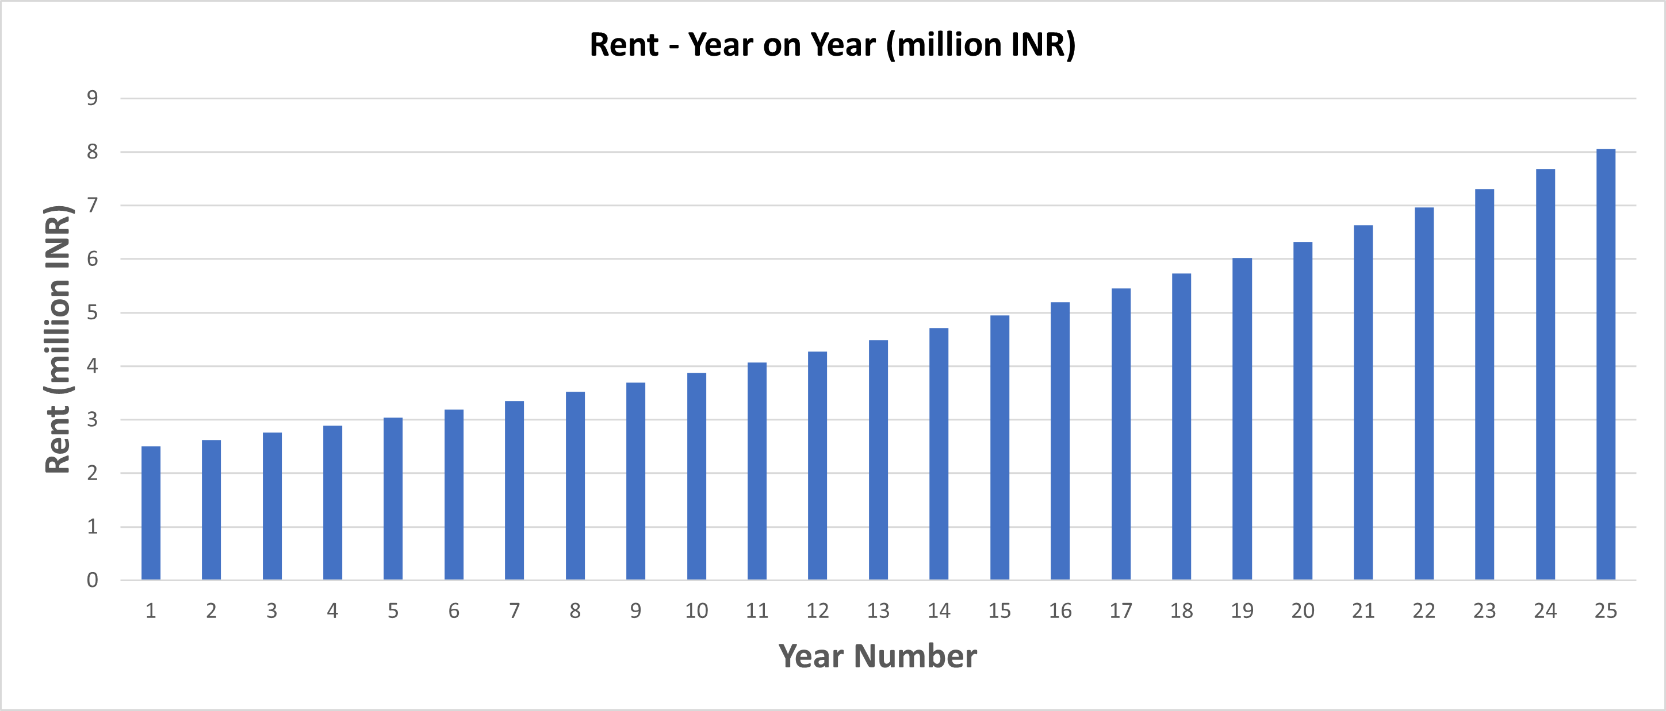

Figure 1 Rent analysis of project (year on year)

## **3.3. Interest on Deposit:**

This column represents the interest earned on the rental deposit, calculated based on the deposit amount and the interest rate mentioned.

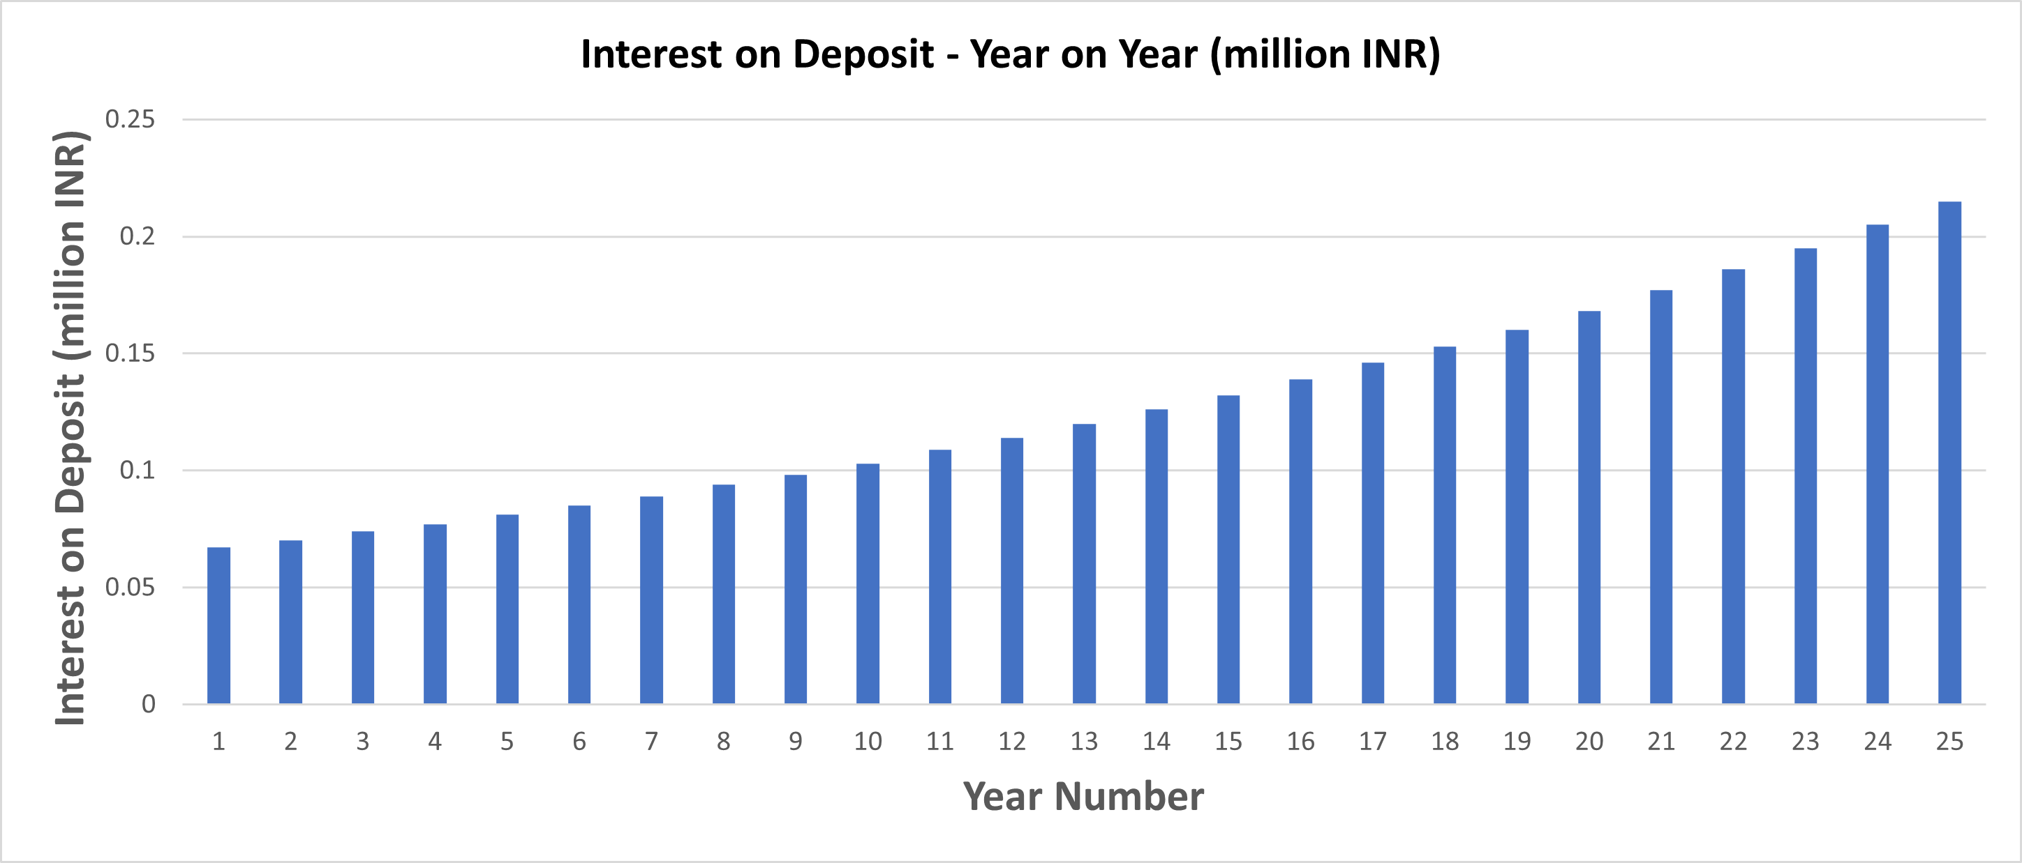

Figure 2 Interest on deposit analysis of project (year on year)

## **3.4 Revenue (million INR):**

This column represents the total revenue generated each year, calculated by multiplying the number of occupied units by the monthly rent and summing up the interest earned on the deposit.

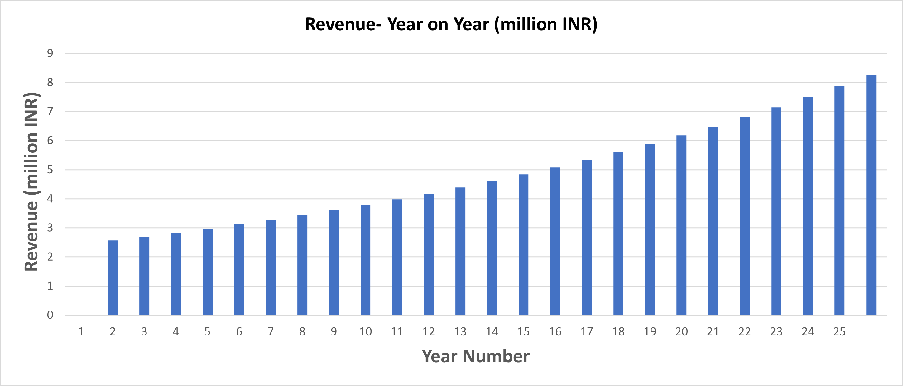

Figure 3 Revenue analysis of project (year on year)

# **Finance Flow**

Financial flow refers to the movement of funds or money within a financial system. It represents the inflows and outflows of cash or financial resources in a given period. Financial flows can occur between individuals, businesses, financial institutions, governments, and other entities.

Financial flow encompasses various types of transactions, including:

**Revenue and Income:** The money earned or generated from the sale of goods or services, investments, or other sources.

**Expenses and Costs:** The money spent on operating costs, purchases, investments, debt repayment, taxes, and other expenditures.

**Investments and Capital Expenditures:** The funds allocated for acquiring assets, expanding operations, research and development, or any other capital-intensive activities.

**Financing Activities:** The inflow and outflow of funds related to debt financing, equity financing, or other forms of capital raising.

**Dividends and Distributions:** The payments made to shareholders or partners as a share of profits or distributions from investments.

**Debt Repayment and Interest Payments:** The repayment of principal amounts and interest on borrowed funds.

**Cash Inflows and Outflows:** The movement of cash into and out of an organization, including cash receipts, cash payments, and cash equivalents.

**Considering :**

|  |  |
| --- | --- |
|  | Today |
| Cost (million INR) |  |
| Land Cost | 20 |
| Construction Cost | 80 |
| Total Cost | 100 |

## **EBITDA Analysis : (Earnings Before Interest, Taxes, Depreciation, and Amortization)**

EBITDA stands for Earnings Before Interest, Taxes, Depreciation, and Amortization. It is a financial metric used to measure the operating performance and profitability of a company. EBITDA represents the company's earnings or operating income before deducting interest expenses, taxes, and non-cash expenses like depreciation and amortization.

In the given context, the figures represent the EBITDA values in million Indian Rupees (INR) for each year from Year 1 to Year 25.

Here's how to interpret the data:

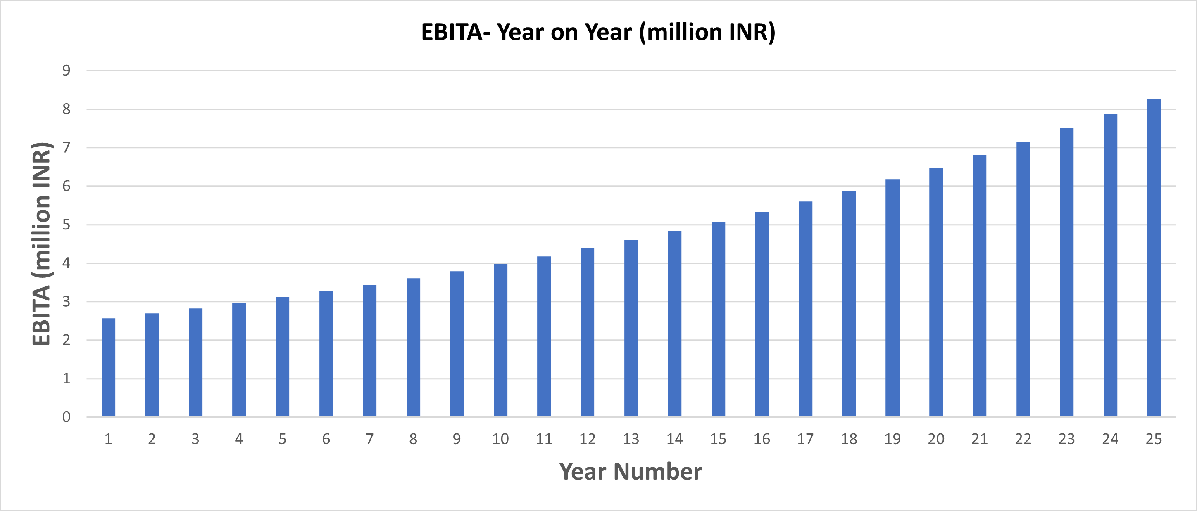

Figure 4 EBITDA analysis of project (year on year)

These figures represent the estimated earnings or operating income of the company before accounting for interest, taxes, depreciation, and amortization expenses for each respective year. EBITDA is often used as a measure of a company's profitability and cash flow generation capacity, as it provides a snapshot of its operating performance without including non-operating factors like financing costs and non-cash expenses.

## **Debt Repayment:**

Debt repayment refers to the act of returning borrowed money or paying off outstanding debts. When an individual or a company borrows money from a lender, they enter into a contractual agreement that stipulates the terms and conditions of the loan, including the repayment schedule.

Debt repayment involves making regular payments, typically on a monthly or periodic basis, to reduce the outstanding debt amount over time. These payments typically consist of both the principal amount borrowed and any interest or fees associated with the loan.

For the project it can be seen as

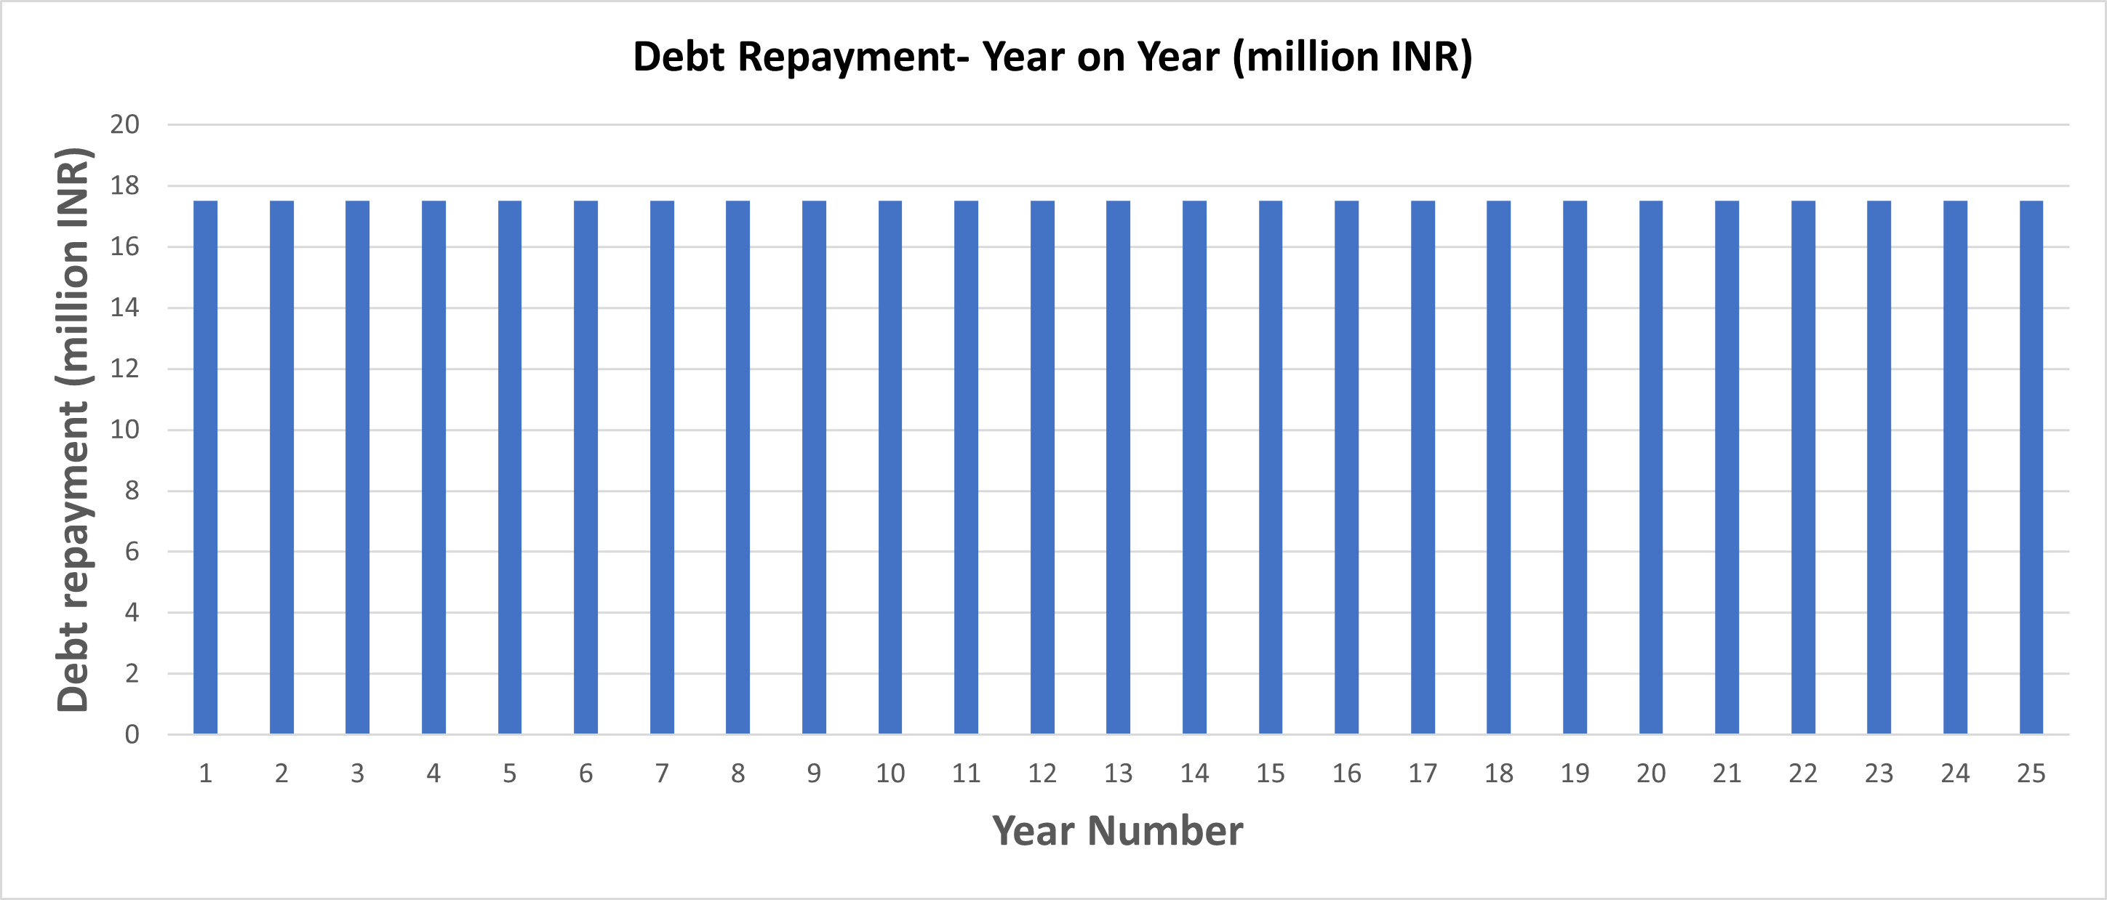

Figure 5 Debt Repayment analysis of project (year on year)

## **EBIT (Earnings Before Interest and Taxes)**

EBIT stands for Earnings Before Interest and Taxes. It is a financial metric that measures a company's profitability before taking into account the interest expense and income tax expenses. EBIT is also known as operating income or operating profit.

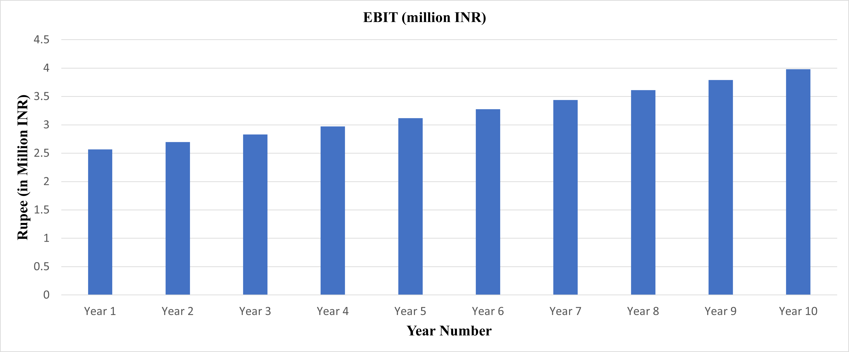

Figure 6 EBIT analysis of project (year on year)

EBIT is calculated by subtracting the operating expenses, such as cost of goods sold, selling and administrative expenses, depreciation, and amortization, from the company's revenue. The formula for calculating EBIT is as follows:

EBIT = Revenue - Operating Expenses

EBIT represents the company's ability to generate profits from its core operations, excluding the effects of interest and taxes. It provides insights into the company's operational efficiency and profitability by focusing on its ability to generate revenue and manage operating costs.

## **Cash Flow**

In finance, cash flow refers to the movement of money into and out of a business or investment over a specific period of time. It represents the net amount of cash and cash equivalents generated or consumed by a company's operating, investing, and financing activities.

Cash flow is an essential metric for evaluating the financial health and performance of a business. It provides insights into the company's ability to generate cash from its operations, meet its financial obligations, invest in growth opportunities, and distribute returns to its shareholders.

In project it can be view as :

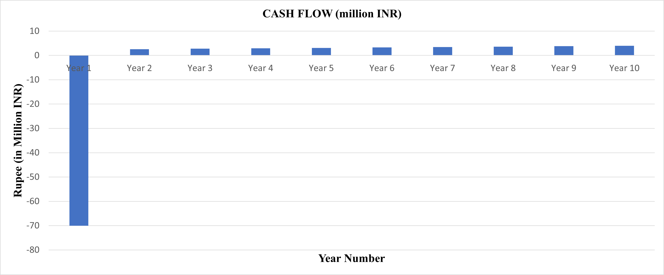

Figure 7 Cash Flow analysis of project (year on year)

## Debt Balance :

Debt balance refers to the outstanding amount of debt owed by a borrower at a specific point in time. It represents the total principal amount that the borrower has borrowed but has not yet repaid. Debt balance can apply to various types of debt, such as loans, bonds, mortgages, or any other form of borrowed funds.

When a borrower takes on debt, they receive an initial loan or credit amount from a lender. Over time, the borrower makes periodic payments, typically including both principal and interest, to reduce the debt balance. The debt balance decreases with each payment until the borrower has fully repaid the borrowed amount, at which point the debt balance becomes zero.

For the given project it can be considered as :

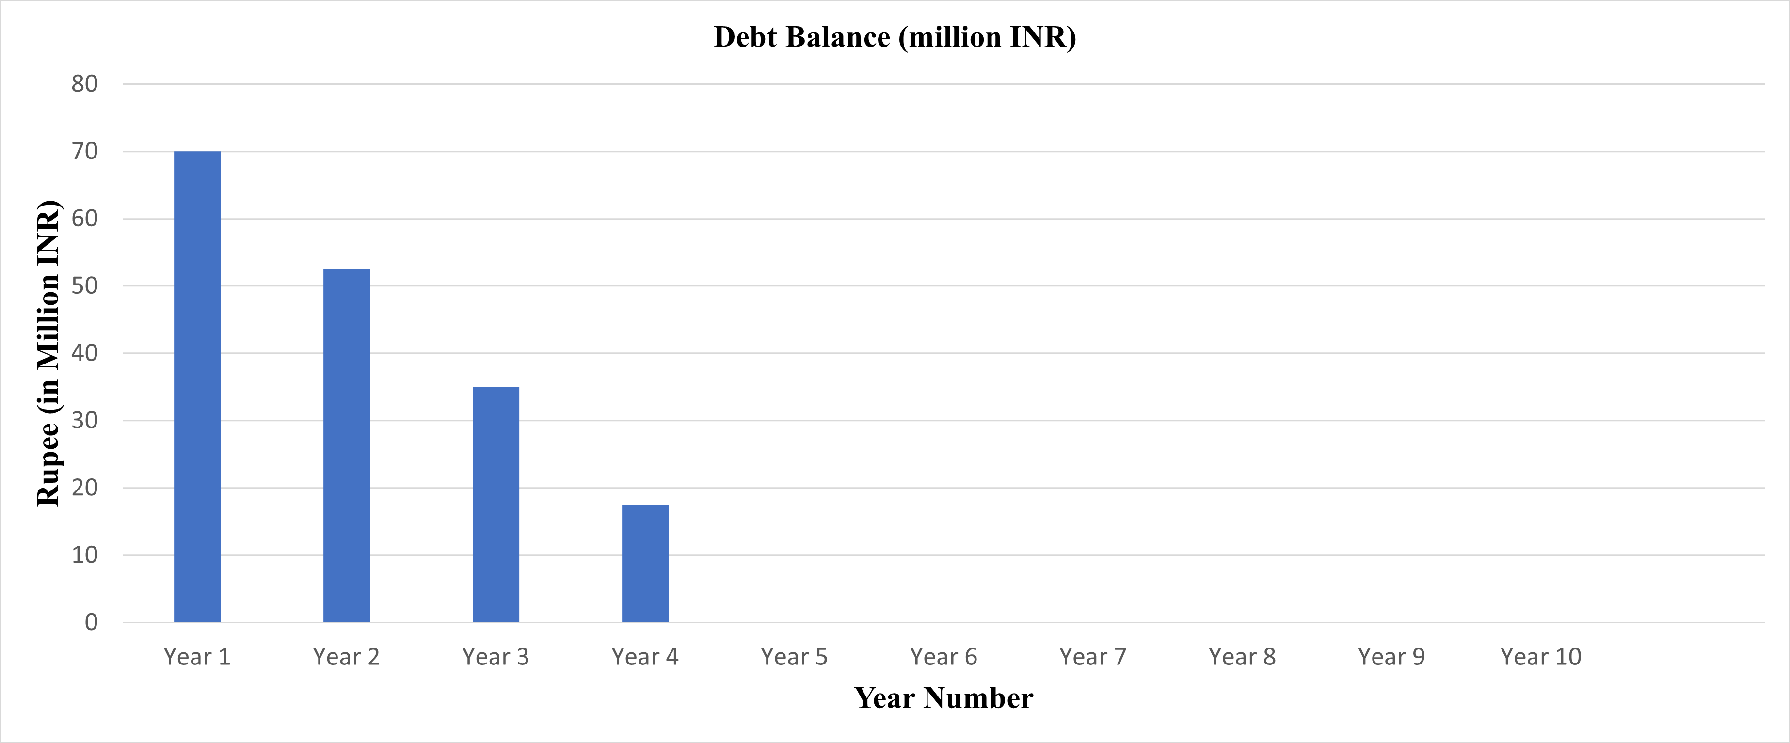

Figure 8 Debt Balance analysis of project (year on year)

# **Result and conclusion :**

In the provided information, there are several financial results and elements mentioned. Let's define each of them and then provide a conclusion regarding the financial model and its potential uses.

**Size in Sq. Ft:**

* Size in Sq. Ft represents the total area or size of the project in square feet. It indicates the physical extent of the property or development.
* Equity:
* Equity refers to the portion of the project's financing that is provided by the project owners or investors.
* In this case, the equity represents 30% of the total financing.

**Debt:**

* Debt represents the portion of the project's financing that is borrowed from lenders or financial institutions.
* In this case, the debt represents 70% of the total financing.

**Debt Service Reserve (DSR):**

* Debt Service Resv (DSR) stands for Debt Service Reserve.
* It represents the number of years' worth of debt service payments that are set aside as a reserve to cover potential defaults or financial difficulties.
* In this case, the DSR is 0.25 years, indicating that 0.25 years' worth of debt service payments are set aside as a reserve.

**Interest rate on Debt:**

* The interest rate on debt represents the percentage rate at which interest is charged on the borrowed funds.
* In this case, the interest rate on debt is 10.0%.

**Equity IRR (Internal Rate of Return):**

* Equity IRR represents the projected return on investment for the equity portion of the project.
* It indicates the rate at which the project's equity investors are expected to earn a return on their investment.
* In this case, the Equity IRR is 23.40%.

**Min DSCR (Debt Service Coverage Ratio):**

* Min DSCR represents the minimum required Debt Service Coverage Ratio.
* Debt Service Coverage Ratio is a measure of a project's ability to generate sufficient cash flow to cover its debt service obligations.
* In this case, the minimum required DSCR is 1.33.

**Avg DSCR:**

* Avg DSCR represents the average Debt Service Coverage Ratio.
* It indicates the average level of cash flow available to cover the project's debt service obligations.
* In this case, the average DSCR is 1.55.

**Project IRR (Internal Rate of Return):**

* Project IRR represents the projected overall rate of return for the entire project, taking into account both equity and debt.
* It indicates the rate at which the project is expected to generate a return on the total invested capital.
* In this case, the Project IRR is 17.20%.

**Conclusion:** The provided financial model incorporates various elements such as project size, equity, debt, interest rate, debt service reserve, and financial performance metrics like Equity IRR, Min DSCR, Avg DSCR, and Project IRR.

Based on the results, it appears that the project has a size of 3,000 square feet, with 30% of financing provided by equity and 70% financed through debt. The project's equity investors can expect an internal rate of return of 23.40%. The minimum required Debt Service Coverage Ratio is 1.33, and the average DSCR is 1.55, indicating sufficient cash flow to cover debt service obligations. The overall Project IRR is 17.20%, representing the expected rate of return for the entire project.

This financial model can be used to evaluate the financial viability and profitability of the project. It provides insights into the project's returns, cash flow, and debt service capacity. Potential uses for this financial model include investment decision-making, project financing negotiations